ASSESSMENT WEEK 3 INSTRUCTIONS
Date:
Tech Name:
Grade:

- Create a new resident in Quail Ridge facility
  - Enter prescriber as Geriatric Doctor
  - Enter allergies as No Known Drug Allergies
- Create a new resident in Concordia Life Care
  - Enter prescriber as Geriatric Doctor
  - Enter allergies as No Know Drug Allergies
- Create a batch in both facilities
  - Batch Name = Your Name
    - If your name is longer than 6 characters just do the first 6 characters of your name
  - Batch Description = Assessment Week 2 for (Your Name)
- Enter orders in DocuTrack under the appropriate facility listed on the document, using the new residents you just created – Each order is worth 10 points each
  - Enter the orders in the batches you created above.
  - For each of the orders, enter the medication using the residents you created above.
- Save your prescriptions
- Send images to PV1
- Email trainer when completed

Order #1
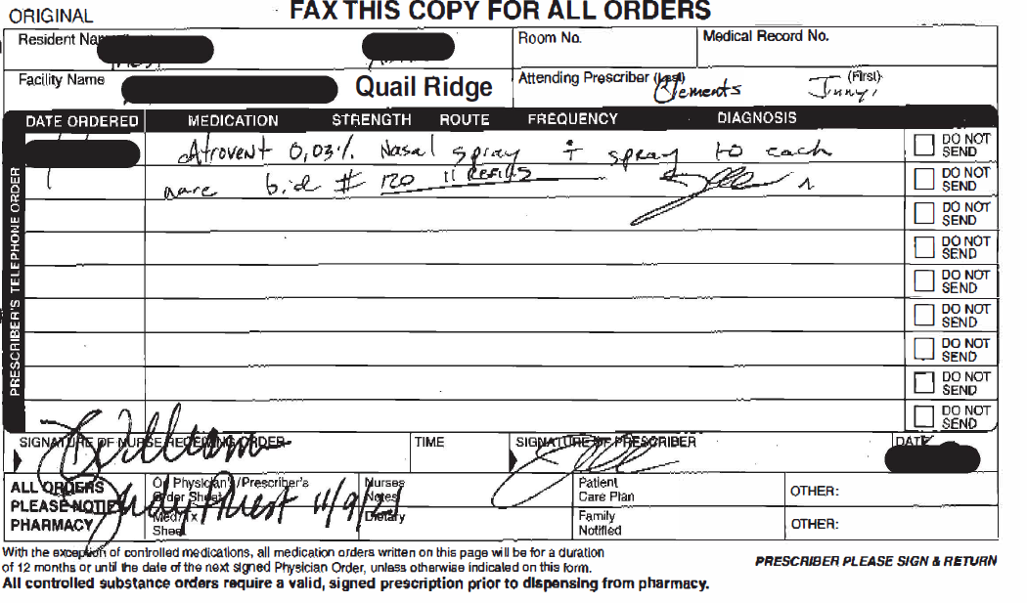

Order #2
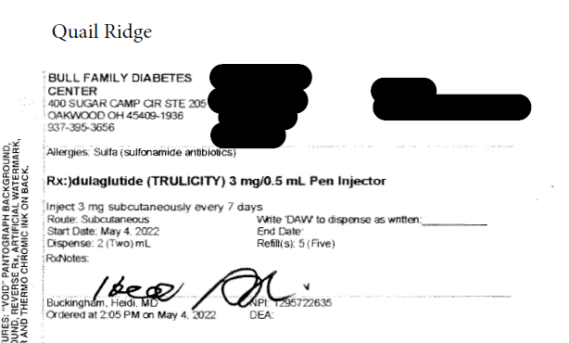

Order #3
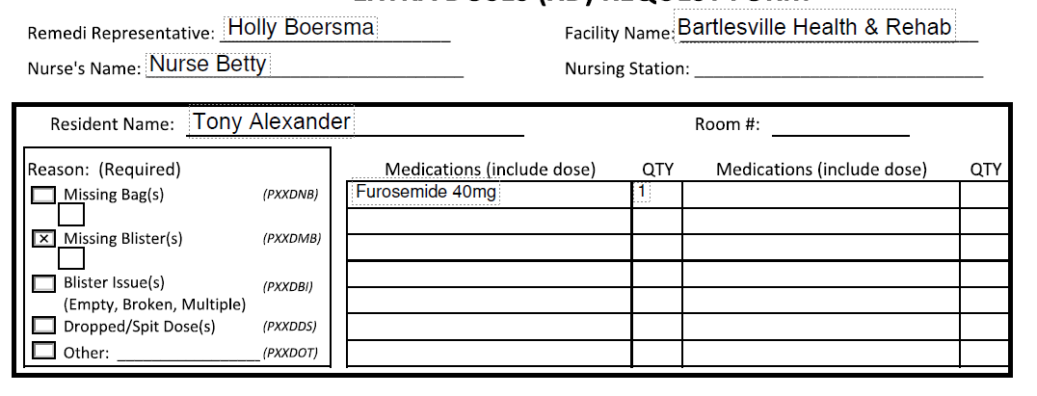

Order #4
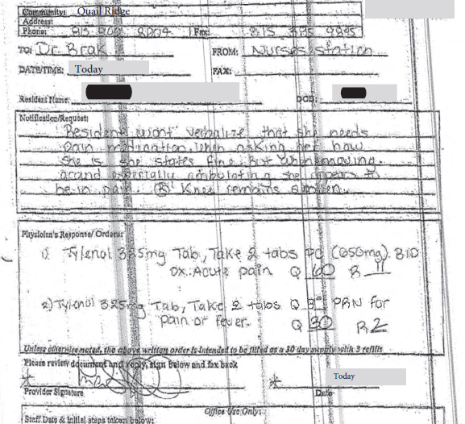

Order #5
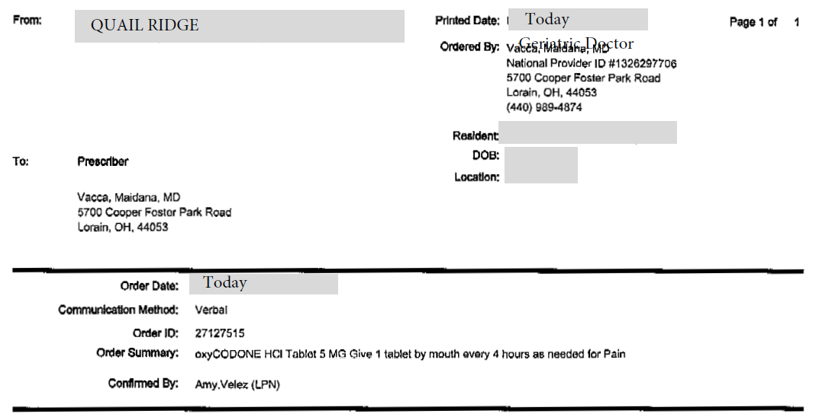

Order #6
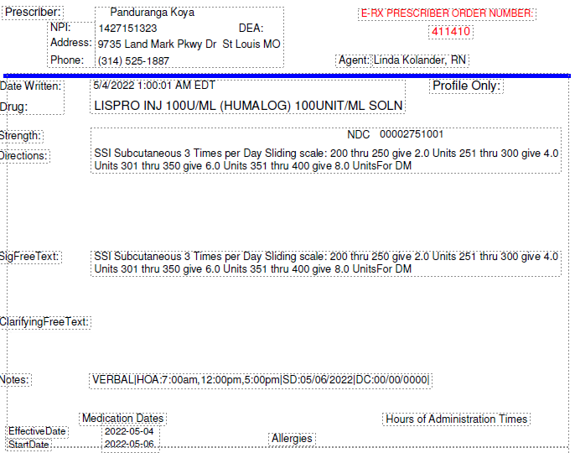

Order #7
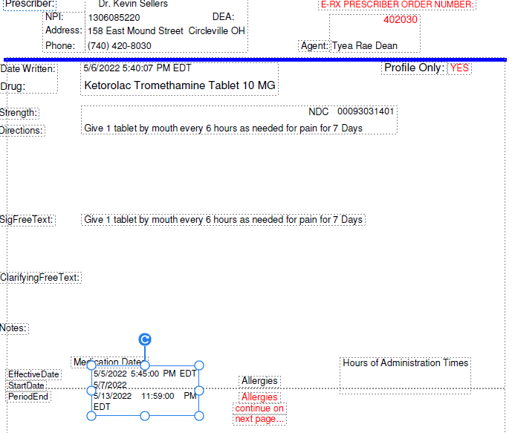

Order #8
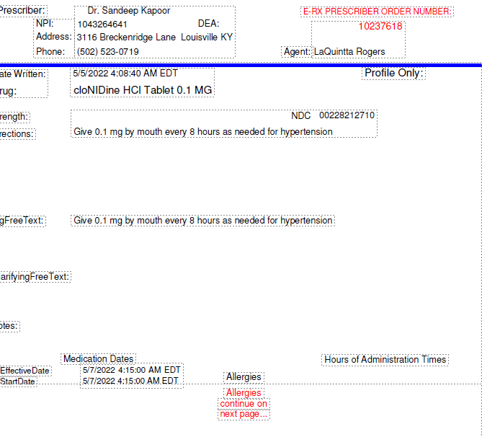

Order #9
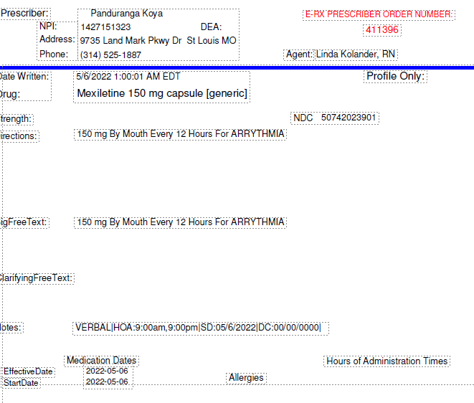

Order #10
